Assoc Prof. LOUISE MCHUGH

School of Psychology, University College Dublin, Ireland

Email: louise.mchugh@ucd.ie • Phone (01) 716 8408

Professional posts
2013-Present Visiting Fellow School of Psychological Sciences & Health,
University of Strathclyde
2017-Present Associate Professor School of Psychology, University College Dublin, Ireland
2012-2017 Lecturer School of Psychology, University College Dublin, Ireland
2004 - 2011 Lecturer Department of Psychology, Swansea University

Education
PhD in Behavioural Analysis (2004) National University of Ireland, Maynooth
BA (Hons) in Psychology (2000) University College Dublin, Ireland

HONOURS & AWARDS
- Outstanding Mentor Award (2010). Association for Behaviour Analysis International Convention
- Fellow of the Association for Contextual Behavioural Science (awarded 2014)

GRANTS & FUNDING
Period | Funding Agency | Amount | Title | Role
2018-2020 | Irish Research Council | €40,000 | Reducing stigma and shame for people experiencing homelessness | PI
2016-18 | Health Research Board | €329,818 | Towards treatment stratification for successful smoking cessation: Harnessing neurocognitive models | CI
2015-18 | Irish Research Council | €77,000 | The contribution of an acceptance and commitment therapy based smartphone application to brief intervention towards smoking cessation outcomes: A randomized control trial | PI
2014-16 | Irish Research Council | €48,000 | Modelling and remediating the impact of cyber exclusion on adolescents | PI
2014-17 | Irish Research Council | €40,500 | Personal impACT: Using ACT training to enhance charisma skills training in organisational populations | PI
2014-15 | Seed Funding, UCD | €5,754 | Identifying neurocognitive endophenotypes  of anxiety versus depression in adolescents | PI
2012-14 | European Commission FP7 - Marie Curie Career Integration Grant | €50,000 | The generalization of self efficacy functions | PI
2012-13 | UCD Seed Funding | €6,000 | Combining novel methods for training perspective-taking with touchscreen technology to create and test a new intervention for children with autism | PI
2011-12 | Welsh Institute for Cognitive Neuroscience | €3,546  €1,773* | EEG correlates of the effects of mindfulness on recognition memory | CI
2010-13 | Wales Office of Research and Development for Health and Social Care | €63,836 | Development of a novel mode of service delivery for a psycho-social intervention (PH-ACT) to promote autonomy in socially-isolated older | PI
2008-10 | The Waterloo Trust | €34,282  €17,141* | Structural and cognitive changes in the postpartum brain: A pilot study | CI
2008-09 | The Leverhulme Trust | €42,402  €21,201* | Mechanisms underlying transfer of function after evaluative learning | CI
2006-07 | British Academy (BARDA) | €50,991 | Semantic network growth: the relative contribution of stimulus frequency, reinforcement, and time of acquisition | PI
*Indicates amount of grant attributed to PI. Award amounts have been converted into Euros

Publications
McHugh has published over 80 peer-reviewed articles in major international journals with 2402 citations including Consciousness & Cognition, Journal of the International Neuropsychological Society, and World Journal of Biological Psychiatry.

Citations by Year:

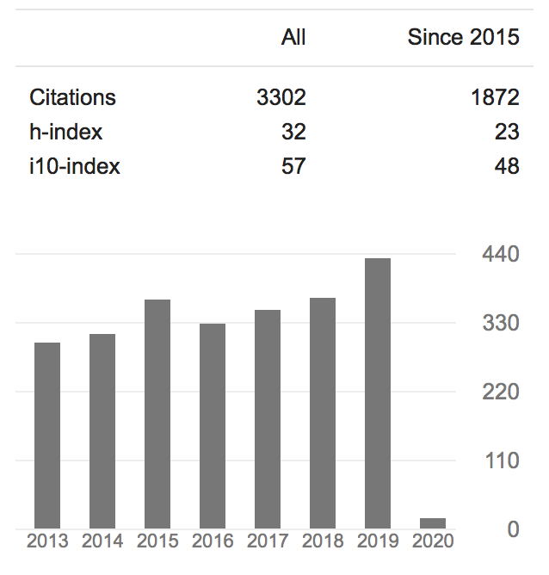

Representative Publications

(1) Larsson, A., Hooper, N., Osborne, L., A., Bennett, P., & McHugh, L. (2016). Using brief cognitive restructuring and cognitive defusion techniques to cope with negative thoughts. Behavior modification 40 (3), 452-482

(2) McHugh, L. (2015). A contextual behavioural science approach to the self and perspective taking. Current Opinion in Psychology 2, 6-10

(3) Hassoulas, A., McHugh, L. & Reed, P. (2014). Avoidance and behavioural flexibility in obsessive compulsive disorder. Journal of anxiety disorders, 28 (2), 148-153

(4) McHugh, L. & Wood, R.L. (2013). Stimulus over-selectivity in temporal brain injury: Mindfulness as a potential intervention. Brain Injury, 27, 1595-1599.
(5) McHugh, L. Procter, J., Herzog, M., Schock, A. & Reed, P. (2012). The effect of mindfulness on extinction and behavioral resurgence. Learning and Behavior, 1-11.
(6) McHugh, L. & Stewart, I. (Eds). (2012). Perspective taking and the self: Contributions and Applications from Modern Behavioral Science. New Harbinger.
(7) Hooper, N., Sandoz, E.K., Ashton, J., Clarke, A. & McHugh, L. (2012). Comparing thought suppression and acceptance as coping techniques for food cravings. Eating Behaviors, 13, 62-64.
(8) McHugh, L. (2011). A New Approach in Psychotherapy: ACT (Acceptance and Commitment Therapy). World Journal of Biological Psychiatry. 12, 76-9.
(9) Hooper, N., Davies, N., Davies, L. & McHugh, L. (2011). Comparing thought suppression and mindfulness as coping techniques for spider fear, Consciousness and Cognition, 20, 1824-1830.
(10) McHugh, L., Simpson, A., & Reed, P. (2010). Mindfulness as a potential intervention for stimulus over-selectivity in older adults. Research in Developmental Disabilities, 31, 178-184.

Citizenship to Profession
- Associate editor Journal of Contextual Behavioural Science
- Guest editor for Special issue on Derived Relational Responding and Autistic Spectrum Disorders, Research on Autistic Spectrum Disorders.
- Reviewer for ESRC, British Academy, and Welcome Trust.
- Conference Chair (2014). UK and Ireland ACT and Contextual Behavioural Science Conference.
- Elected Board Member at Large Association for Contextual Behavioral Science (2014-16).
- Conference Strategy Committee (2012 – present). Association for Contextual Behavioural Science.
- Conference Programme Chair Association for Contextual Behavioral Science, World Conference Dublin 2019.

ADMIN and Teaching UCD

- Global engagement officer School of Psychology
- College of Social Science and Law Internationalisation Committee board member
- Academic Director Masters in Mindfulness Based Interventions
- Erasmus coordinator School of Psychology
- School of Psychology Teaching and Learning committee member
- Module Coordinator for 2 UG modules and 4 PG modules.
- Project supervision per year: 5 UG; 2 MSc; 1 DClin
- Director of the UCD CBS lab – 13 members (RAs, PhDs, Post Docs).

